Biosignal recognition training tool

Anzhelina Andriyanova and Angèle Umba

Supervisor: Prof. Dr. Paul Devos

Academic year: 2017 – 2018

Content table

Introduction 1

Program: C# 1

Layout 2

Main window 2

Tabs 3

Training 3

Learning 4

Exam 5

Add 6

Database 6

Appendix 6

1. Images of the main window 6

2. Images of the training session 8

3. Images of the learning session 9

4. Images of the exam session 10

5. Images of the add tab 12

Introduction

The goal for this project is to create a training tool to gain the knowledge of heart- and lung sounds. The user will have the possibility to become familiar with several sounds of normal and abnormal hearts and lungs due to a program in C#. A database which contains the basic characteristics of the wav-files is integrated in a WPF-application. The graphical properties are stored in a xmal-file while the logic linked to the design can be found in the xmal.cs-file. The corporate identity of UGent was used as a reference to decide which colors and font-family to implement.

There are four tabs available once the application is launched: training, learning, exam and add. Each of those tabs are sessions which provides their own functionalities.

Program: C#

As mentioned before, WPF-application is used to accomplish the goal of this project. WPF stands for Windows Presentation Foundation which is Microsoft’s latest approach to create a graphic user interface (GUI). This allows you to dynamically use a wide range of GUI elements as textboxes, buttons, etc. These elements can be modified in a .xmal-file. A preview of how your GUI will look like gets refreshed every single time you change something in this file. To make those elements interact with each other or other xmal-files, a xmal.cs-file is linked. All the logic can be stored in there to make the application operational.

This project contains four xmal-files and equally as many xmal.cs-files. These have been implemented separately to create a distinct separation between all the tabs.

The main window serves as an entry to all the different tabs. A START-button has been linked to three of the four tabs, and a HOME-button will do the exact opposite. Tab ***Add*** doesn’t have a separate xmal-file because the corresponding logic is minimal.

All the implemented tabs will be describes thoroughly and illustrated in the next sections.

Layout

To make this application user-friendly, it’s important for the layout to be structured. The GUIs can be decorated in different colors for that matter or placed on a blank space on the window. Because the implementation of the colors and the alignment is straightforward, only grid definition will be described based on figure 1. The exact height and width is described together with the title of the xmal-file. In this case has a height of 350 and width of 525 which results in a rectangle. Taking this in consideration, the second step is to define the desired amount of columns and rows. In this case three columns and two rows are picked. Each column can only have a width as a row can only have a height. The asterisk next to the number to give the width and height a specific value denotes the fact that every column and row have a relative width/height. So a width of 4* is equal to:

$\frac{525}{(4+5+4)} x 4=40,38 x 4=161,54$

The same logic applies on the rows. Now, to place a GUI element somewhere, stackpanels are created to pick a smaller rectangle from the main rectangle characterized by the defined columns and rows. For example, the stackpanel defined in figure 1 is the rectangle 1.

|  |
| --- |
| …  Title="Exam" Height="350" Width="525">  …  <Grid>  3  2  1  …  <Grid.ColumnDefinitions>  <ColumnDefinition Width="4*"/>  <ColumnDefinition Width="5*"/>  6  5  4  <ColumnDefinition Width="4*"/>  </Grid.ColumnDefinitions>  <Grid.RowDefinitions >  <RowDefinition Height="*"/>  <RowDefinition Height="4*"/>  </Grid.RowDefinitions>  …  <StackPanel Orientation="Vertical" Grid.Column="0" Grid.RowSpan="0" VerticalAlignment="Center">  …  </StackPanel>  …  </Grid> |

Figure 1: The way a window gets structures by using the grid

This method has been used to place all the GUI elements on the windows to create a pleasing view.

Main window

This window can be considered as the general input of this project. Not only is this the entry to the different xmal- and xmal.cs-files, but also a way to enter other wav-files in the database that is available at the launch of this application.

The windows of all the possible tabs are shown in appendix 1 from up to bottom. Each tab except the ***add*** tab contains a button and a text block. To initiate those tabs in the main window, a snippet of the code is shown in figure 2.

|  |
| --- |
| <TabControl Background="White">  <TabItem Header="Training" Background="LightSkyBlue">  …  </TabItem>  <TabItem Header="Learning" Background="LightSkyBlue">  …  </TabItem>  <TabItem Header="Exam" Background="LightSkyBlue">  …  </TabItem>  <TabItem Header="Toevoegen" Background="LightSkyBlue">  …  </TabItem>  </TabControl> |

Figure 2: Code of the xmal-file to implement the several tabs in the main window.

An introduction is given while residing on a specific tab to prepare you to start a session.

Tabs

This project provides different learning experiences which are integrated in the three tabs described below. The training session creates the opportunity to become familiar with the different heart and lung sounds which are fetched from the database. Secondly, the test session fabricate a concatenation of four sounds, four times in a row in a random sequence as a multiple choice test. Lastly, there is an exam session where one can test their skills by writing the abnormalities of the heart sounds that are playing in the background.

To view the several windows, there are images available in the appendix.

Training

This session provides an opportunity for the user to become familiar with the sounds provided to broaden the current knowledge on the recognition of several biosignals.

The window shown at the top image in appendix 2 is the first one seen once the training session is started. The first heart sound in the database is set as a default value to prevent errors once the play button is pressed. Besides playing the sounds that the user picked, there is also an opportunity to pause, stop and regulate the volume as desired.

A combobox linked to the database shows the selection of the sounds which were inserted, seen on the middle image in appendix 2. Whenever the timespan continuously changes its value, it’s an indication that there is a sound that’s playing as seen in the bottom image.

Using the variables implemented in the xmal-file of the training session seen in figure 3, functionalities can be linked to each action.

|  |
| --- |
| <MediaElement Source="C:\Users\angel\Documents\biomedische\Biosignal-recognition-training-tool\WpfApplication1\Heart sounds wav\001. Normal Heart Sound- normal speed.wav" Name="myMediaElement" Width="50" Height="50" LoadedBehavior="Manual" UnloadedBehavior="Stop" Stretch="Fill" MediaEnded="Element_MediaEnded"/>  …  <ComboBox Name="KeuzeSound" SelectionChanged="KeuzeSound_SelectionChanged" Width="200" Height="30" SelectedIndex="0">  …  <Label Name="lblStatus" Content="Not playing..." HorizontalContentAlignment="Center" VerticalContentAlignment="Center" Margin="5" />  …  <Button x:Name="btn1" Content="Play" Click="ButtonPlay" Width="100" Height="30" Background="LightSkyBlue" />  <Button x:Name="btn2" Content="Pause" Click="ButtonPause" Width="100" Height="30" Background="LightSkyBlue"/>  <Button x:Name="btn3" Content="Stop" Click="ButtonStop" Width="100" Height="30" Background="LightSkyBlue"/>  <TextBlock VerticalAlignment="Center" Margin="5" >Volume:</TextBlock>  <Slider Name="volumeSlider" VerticalAlignment="Center" ValueChanged="ChangeMediaVolume" Minimum="0" Maximum="1" Value="0.5" Width="70"/>  … |

Figure 3: Code of the xmal-file to implement the general functionalities in the training session

Due to a reused logic of the way sounds can be manipulated, a breakdown of how it happens will be described in this section.

The few variables used to do so is ***myMediaElement, KeuzeSound(_SelectionChanged), lblStatus, ButtonPlay, ButtonPause, ButtonStop*** and ***VolumeSlider***. Their functionalities goes as follow:

* ***myMediaElement***: the current sound that’s playing in the background represent this variable. It’s the name given to the GUI element responsible to handle sounds files.
* ***KeuzeSound***: the specific sound picked in the combobox. This is linked to a path to the database
* ***KeuzeSound_SelectionChanged***: this reallocates the path of the sound whenever another sound is picked from the combobox.
* ***lblStatus***: this projects the timespan of the sound by continuously checking whether the sound is playing. The timespan increments by the second as long as the pause or stop button is not pressed.
* ***ButtonPlay***: the on click action linked to the play button. By pressing this, the timer starts together with the sound and increments the timer (projected on the lblStatus) until the end of the sound (or the other two buttons are pressed)
* ***ButtonPause***: pauses the sound and freezes the timespan
* ***ButtonStop***: stops the sound and resets the timespan
* ***VolumeSlider***: alters the volume by choosing a minimum, maximum and default value. Ours is set right in the middle.

Inherent libraries were used to implement these variables were used to execute these functionalities.

To terminate this training session, it’s sufficient to click on the home button to be brought back to the main window to access other sessions.

Learning

In this session the user needs to recognize one sound among a mix of 4 sounds, 4 times (16 sounds), point it out and submit it. Right after that, the correct answer gets projected immediately after submitting their choice. Only if the correct answer is submitted, another set of mixes gets prepared and other answer possibilities. This can go on as long as the user wish for and can be closed when pressing on the home button.

The first image in appendix 3 is the first view of the learning session. Compared to the previous session, a few GUI elements were kept the same (the timespan and the volume slider). Actually, the four option buttons can be considered as play buttons, but instead of one song there are a mix of 4 songs created. The mix are different sounds concatenated after one another. On figure 4 there is an implementation in the layout of the significant essentials of this session.

|  |
| --- |
| …  <Button Width="100" Height="30" Background="LightSkyBlue" Click="Button_Click">Submit</Button>  …  <Button x:Name="btn4" Content="Keuze 4" Click="Button_Click4" Width="100" Height="30" Background="LightSkyBlue"/>  <ComboBox Name="cbAntwoorden" Width="100" Height ="30" Background="LightSkyBlue" SelectionChanged="ComboBox_SelectionChanged" SelectedIndex="0" ></ComboBox> |

Figure 4: Code of the xmal-file to implement the general functionalities in the learning session

The mixes are produced on the occasions: at the start of this sessions and after submitting a good answer checked by the function ***CheckAnswer***. Therefore it is necessary to implement the function ***MixingSongs*** in ***GenerateNextQuestion***. What these function do in detail is the following:

* ***MixingSongs***: [Anjaaa???]
* ***GenerateNextQuestion***: this is going to run the previous function once.
* ***CheckAnswer***: the answer picked in the combobox ***cbAntwoorden*** is compared with the correct answer. If this is not the case, a messagebox will pop on the screen as seen in the second image in appendix 3. This will contain the right answer. If the correct answers has been submitted, ***GenerateNextQuestion*** will be generated and the default value of the combobox will be set on the first possible answer for the next question.

Now how does the submit button function? And what is so different on the option buttons compared to the standard play buttons? The on click actions are ***Button_Click*** and ***Button_Click4*** for the fourth option (the last number varies depending from which button it’s linked to).

* Button_Click: Not only does this action generate ***CheckAnswer***, but it also serve as stop button. The source of the sound also gets reset to prevent conflicts between two sounds.
* Button_Click4: the difference with a normal play button is that the source of the sound get set to the right location created by the function ***MixingSongs***.

Liked mentioned before, this sequence of creating mixes and answering continues up until the home button is pressed. After challenging your knowledge by repeatedly taking these tests, it’s time to try the exam session.

Exam

[Anjaaa???]

|  |
| --- |
| …  <Label Name="lblq1" Content="Type:"/>  <TextBox Name="tbxQ1" />  …  <Button Name="btnNext" Grid.Column="3" Grid.RowSpan="2" HorizontalAlignment="Center" VerticalAlignment="Center" Content="Volgende" Click="btnNext_Click" Width="100" Height="30" Background="Yellow"/>  … |

Figure 5: Code of the xmal-file to implement the general functionalities in the exam session

Add

[Anjaaa???]

|  |
| --- |
| …  <TextBox Name="txtbxId" Width="130" Height="30"></TextBox>  <TextBox Name="txtbxType" Width="130" Height="30"></TextBox>  <TextBox Name="txtbxAfwijking" Width="130" Height="30"></TextBox>  <TextBox Name="txtbxLocatie" Width="130" Height="30"></TextBox>  …  <Button HorizontalAlignment="Right" Name="saveButton" Click="saveButton_Click" Width="100" Height="30" Background="Yellow">Save changes</Button>  …  <DataGridTextColumn x:Name="idColumn" Binding="{Binding Id}" Header="Id" Width="SizeToHeader"/>  <DataGridTextColumn x:Name="typeColumn" Binding="{Binding Type}" Header="Type" Width="SizeToHeader"/>  <DataGridTextColumn x:Name="afwijkingColumn" Binding="{Binding Afwijking}" Header="Afwijking" Width="SizeToHeader"/>  <DataGridTextColumn x:Name="locationColumn" Binding="{Binding Locatie}" Header="Location" Width="SizeToHeader" />  … |

Figure 6: Code of the xmal-file to implement the general functionalities in the add tab

Database

[Anjaaa????]

Appendix

1. Images of the main window

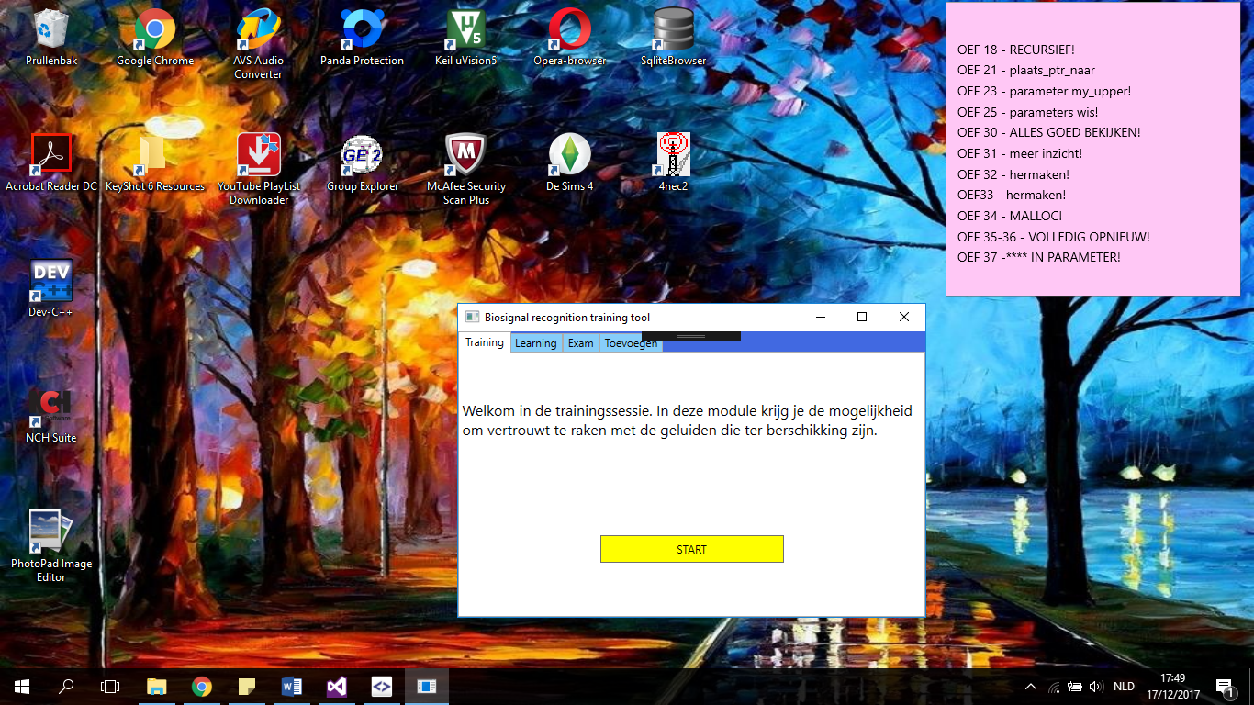

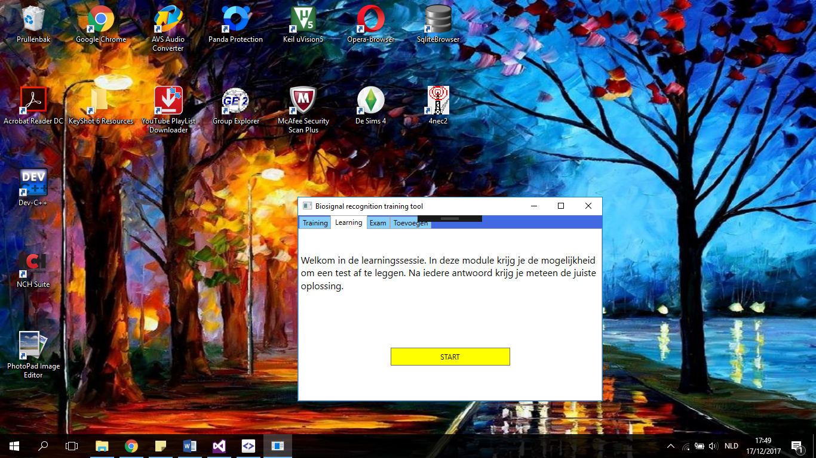

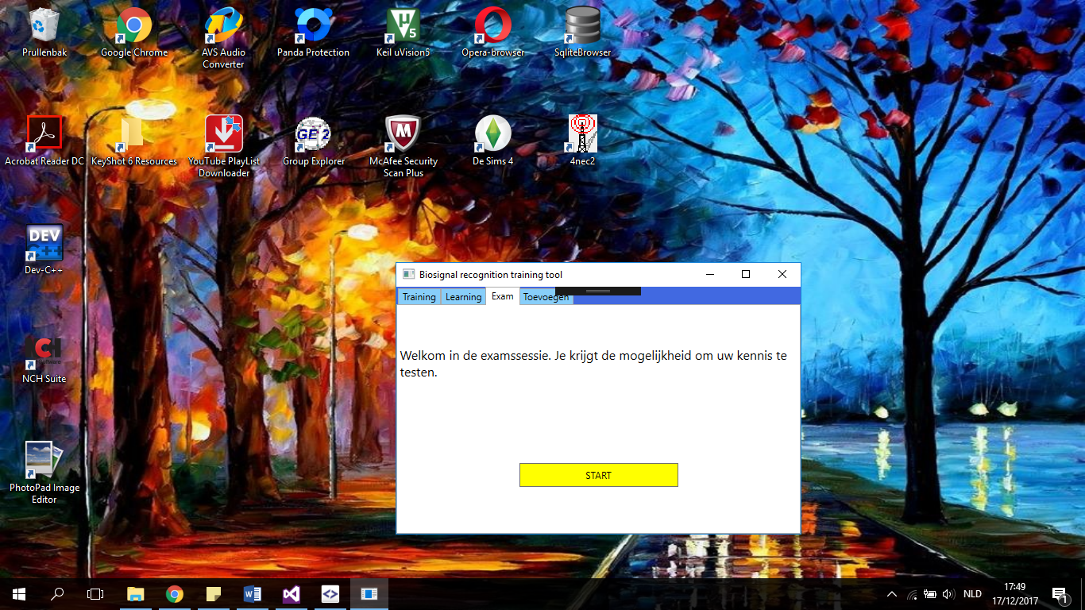

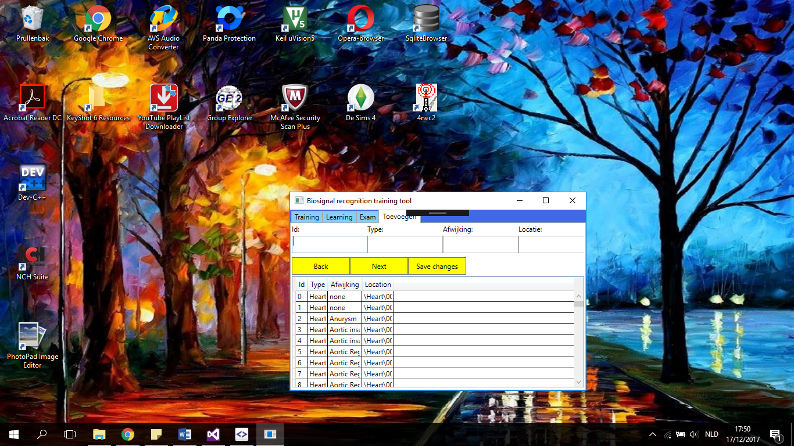

1. Images of the training session

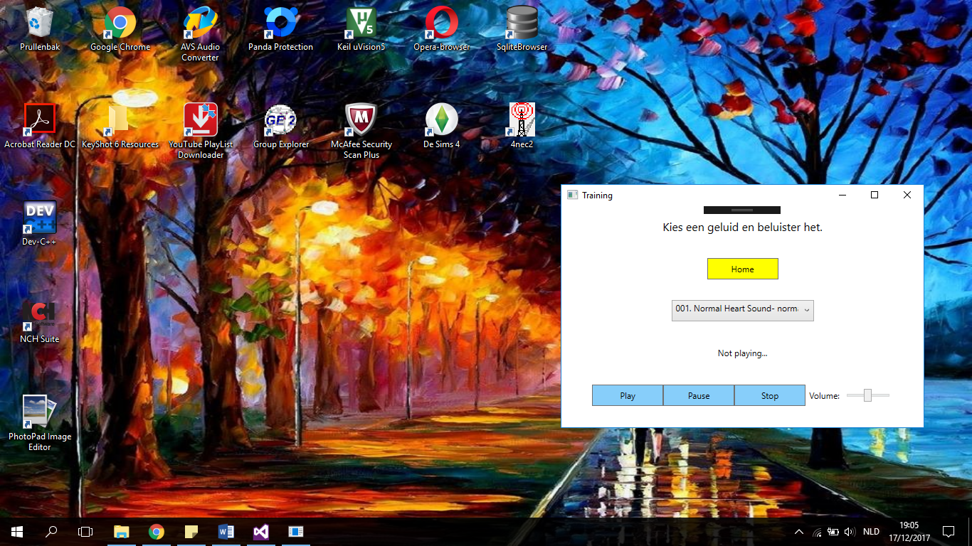

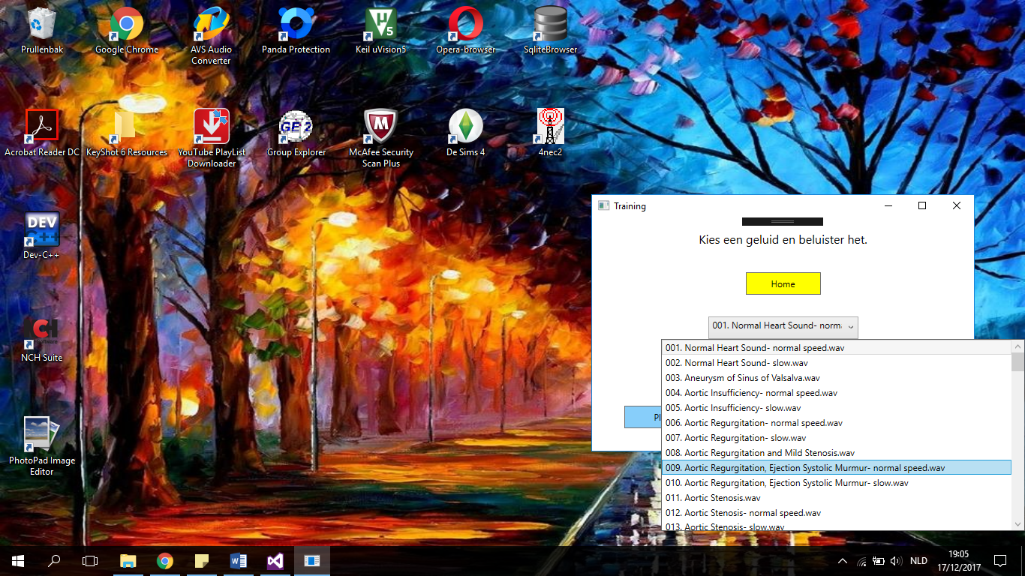

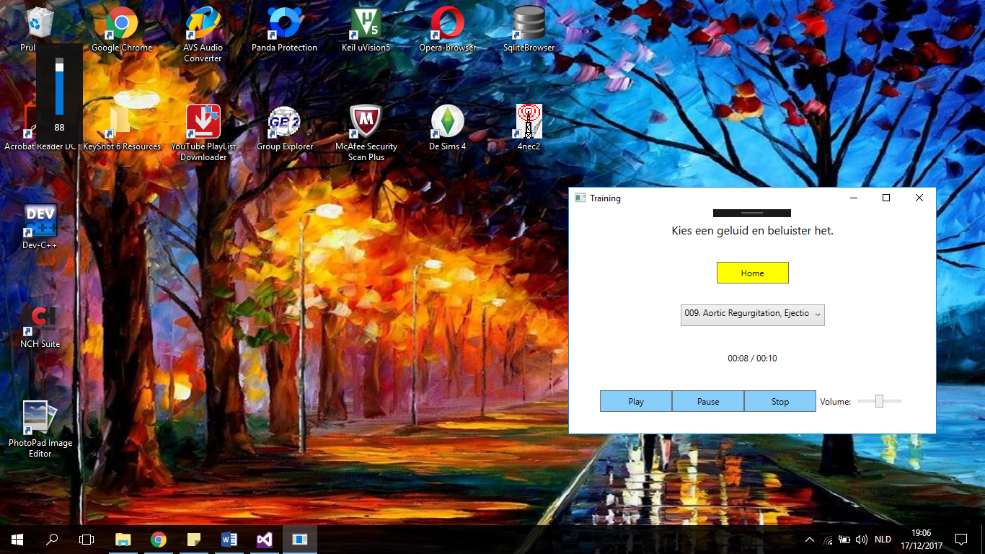

1. Images of the learning session

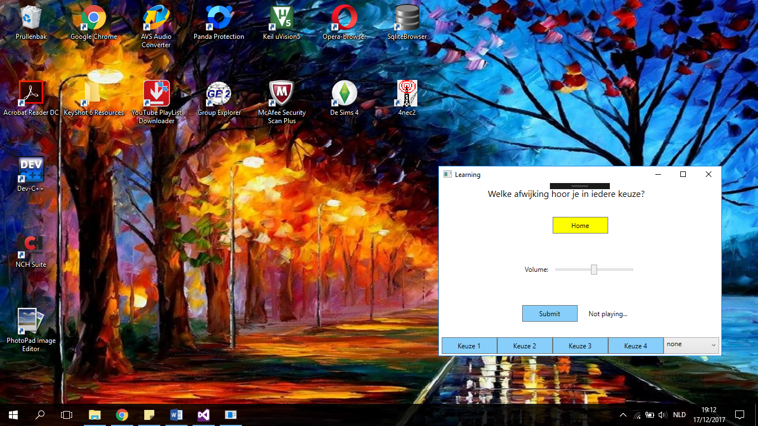

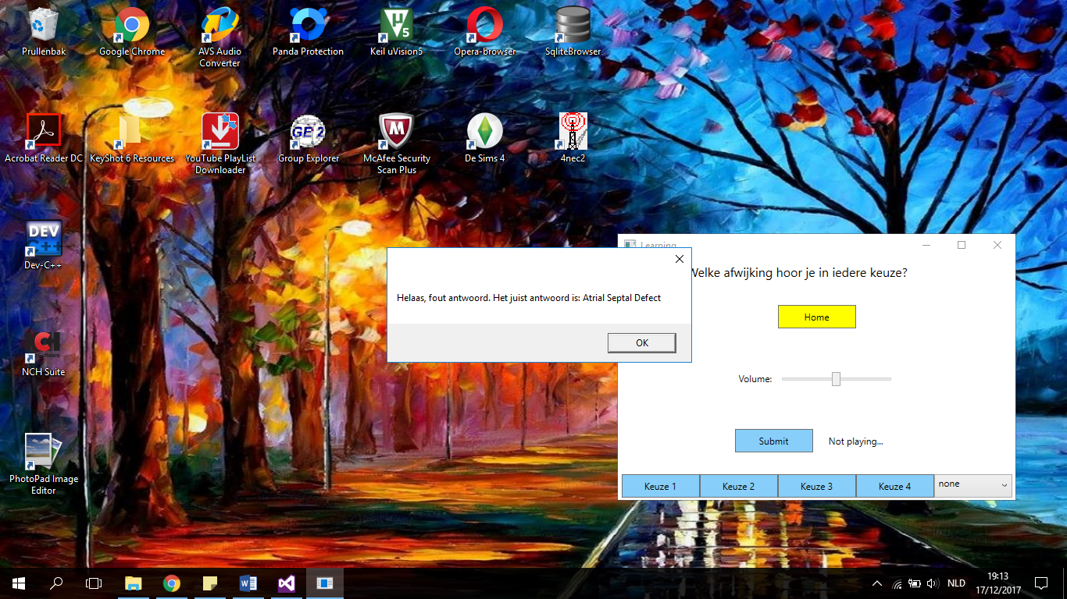

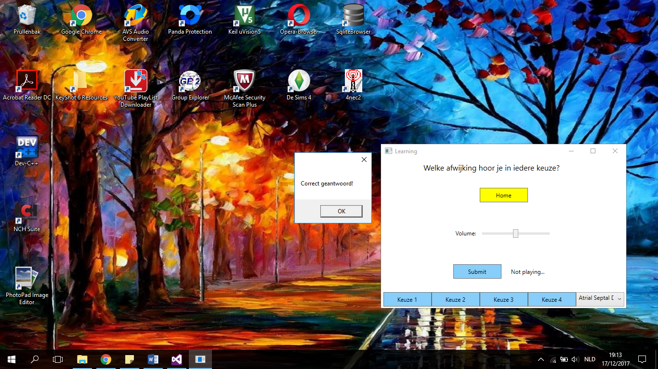

1. Images of the exam session

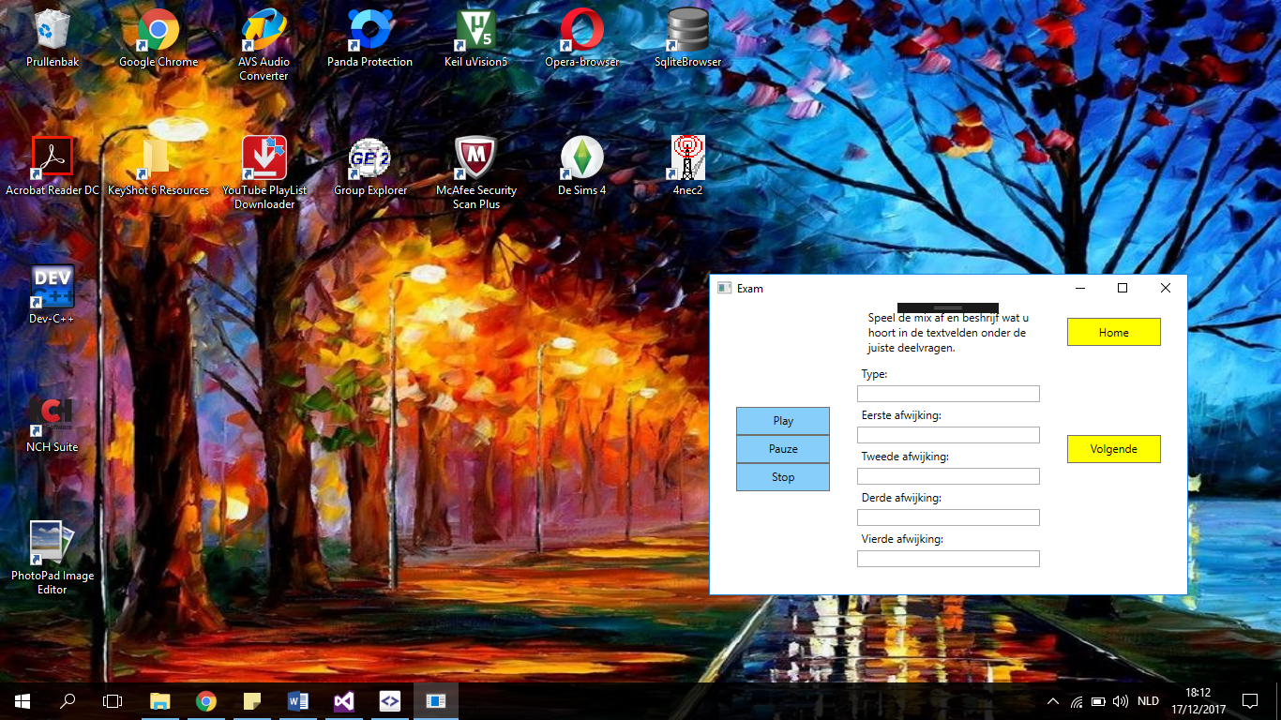

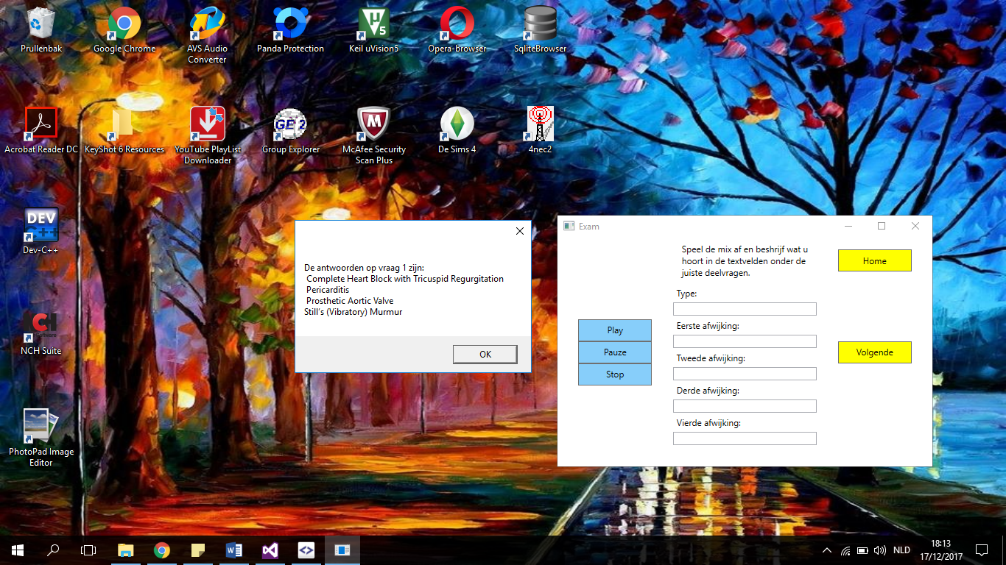

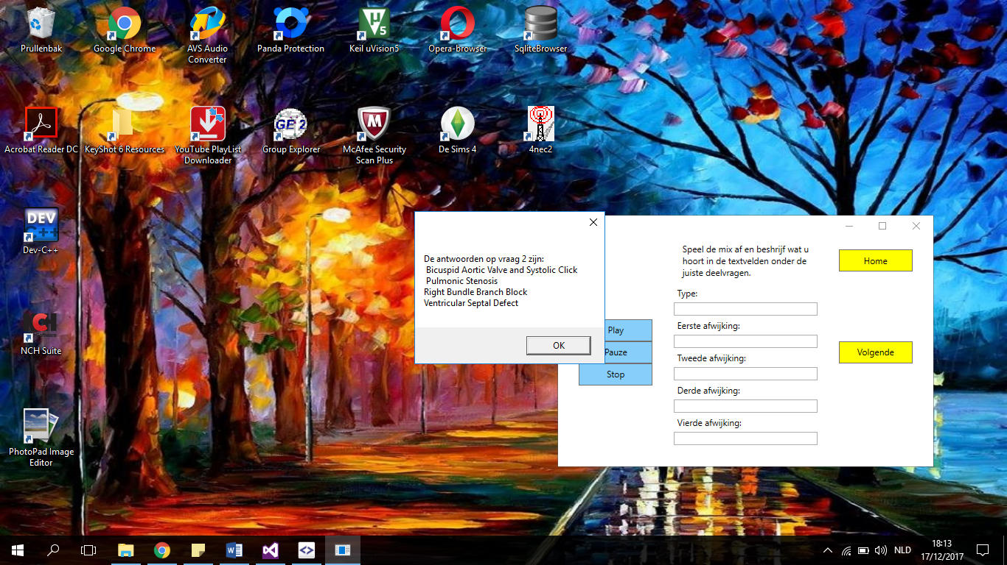

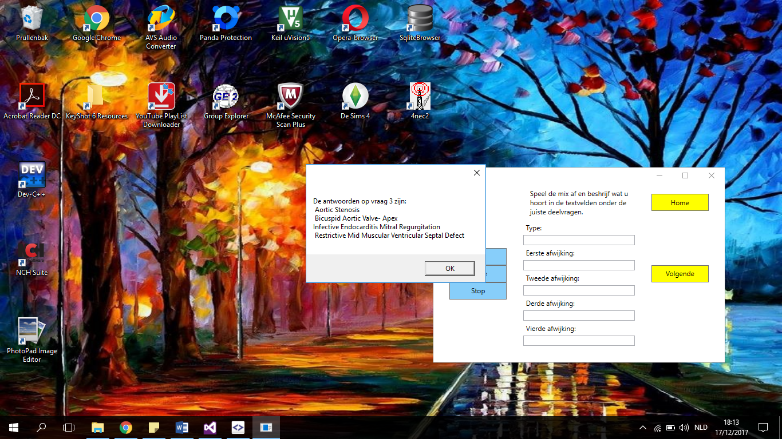

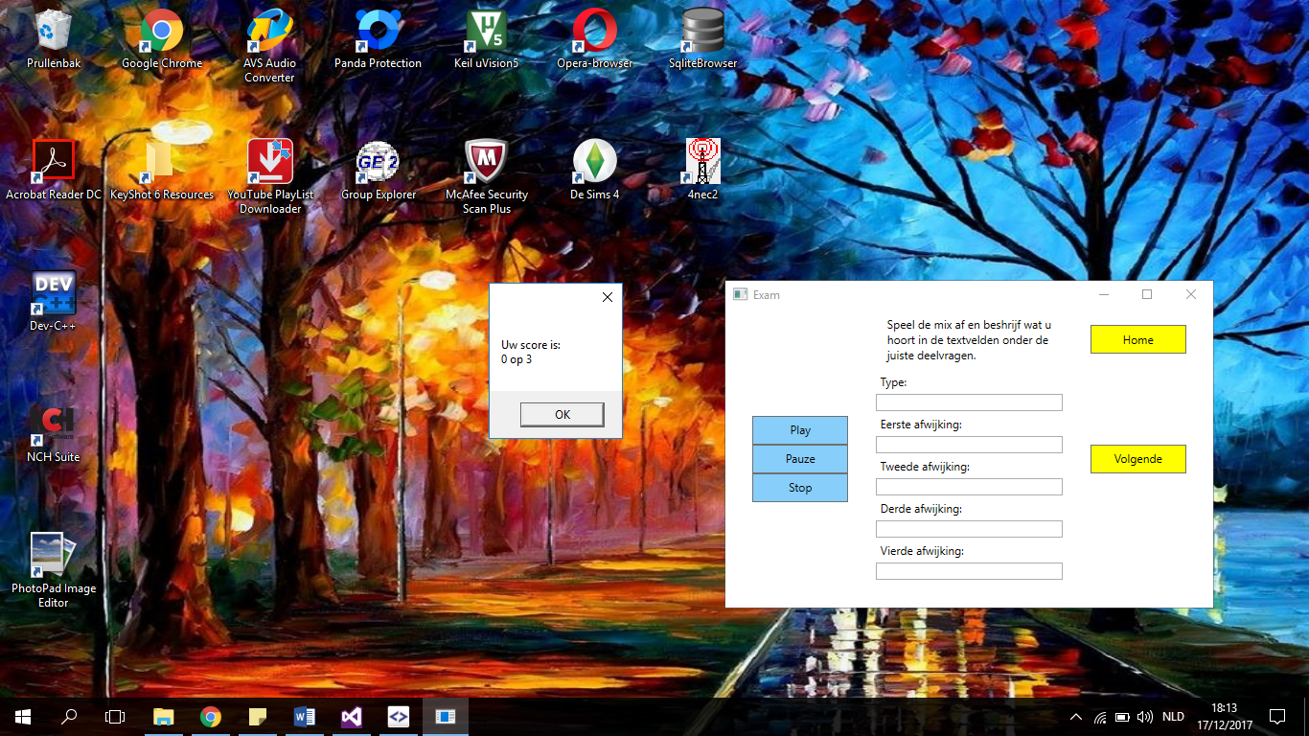

1. Images of the add tab

